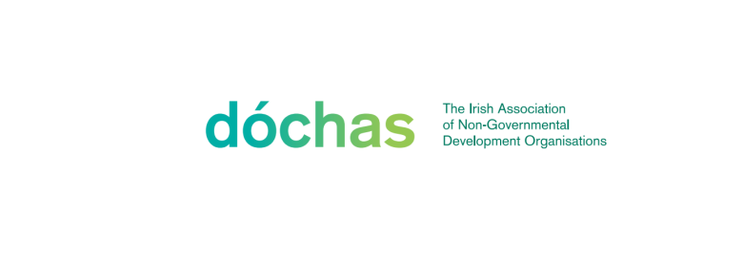

Dóchas Wednesday News Editorial Policy
July 2024

The Dóchas Wednesday News is a weekly informer that shares information about events, workshops, training opportunities, vacancies and other information relevant to the development and humanitarian sector in Ireland. The Newsletter is published weekly on the Dóchas website and shared via email and social media.

What does the newsletter include?

- Dóchas Updates
- Upcoming events and conferences
- Upcoming meetings, seminars and workshops
- Paid vacancies
- Calls for tender
- Internship opportunities
- Courses and Training Opportunities
- Watch and listen
- Other news and information

How to submit?

All submissions should be sent to programmesupport@dochas.ie by 5pm on Monday. Submissions must include a title, short description (max. 100 words), a link for more information or the details of a contact, and a closing date where applicable. Postings take the following format:

Organisation Name: Short Title
Description. Find out more here (hyperlink/contact details ). Closing date: Date Month

Example:

Dóchas: Launch of Wednesday News Editorial Policy
On 1 July 2024 Dóchas will launch the updated editorial policy of the Dóchas Wednesday News. The Wednesday News is a weekly informer, providing updates on events, information and opportunities in the sector. The launch event will take place in the Dóchas office at 2pm. Find out more and register here.

Editorial Policy
- Information on events, job advertisements or items of interest to the sector are carried for a maximum of three issues. This can be extended by an extra week upon request and at the discretion of Dóchas.
- Dóchas reserves the right to decide what information is included in the newsletter.
- Information from non-members is included in Wednesday News at the discretion of Dóchas.
- Submissions for courses, trainings, and workshops should have a non-profit element to them, or, where a fee applies, have the possibility of pro-bono spaces. Dóchas retains the right to include or exclude fee-paying courses, trainings, or workshops in the Wednesday News.
- Dóchas reserves the right to edit any information received, as well as to exercise editorial control over the content of the newsletter.
- Images and promotional material are not included.
- Dóchas Wednesday News is focused on the international humanitarian and development sector in Ireland. It does not include postings related to projects centred on Irish development such as local community initiatives and integration projects.
- Calls for signatures can be included in the “Other News & Information” section at the discretion of Dóchas. All calls for signatures should provide a link for more information which is housed on the poster’s website, rather than a direct link to a sign-up sheet.
- Links to job advertisements should lead directly to the role in question, rather than to the general job portal/page.
- Information for relevant courses and training from private companies and social enterprises may be accepted for a maximum of one edition.
- Postings for positions outside of Ireland are included when they are tied to an Irish humanitarian and development organisation, or to the Irish offices of an international humanitarian and development organisation.
- Dóchas Wednesday News does not include fundraisers or fundraising events.
- Attachments such as Microsoft Word files, Google Documents or PDFs are not included. All links for more information/registration/application must be to a live website such as the organisation’s website or a jobs board.
- Publications and resources are not shared in Dóchas Wednesday News but launch events for such resources are.
- To be considered for inclusion in Dóchas Wednesday News, all information must be received at the Dóchas office by 5 pm each Monday.
- Every effort is made to distribute the newsletter by email each Wednesday at lunchtime.
- Email addresses are posted in the format of programmesupport(at)dochas.ie to prevent Dóchas Wednesday News being scanned for phishing and scamming purposes.

